JGU-Logo_farbe.wmf 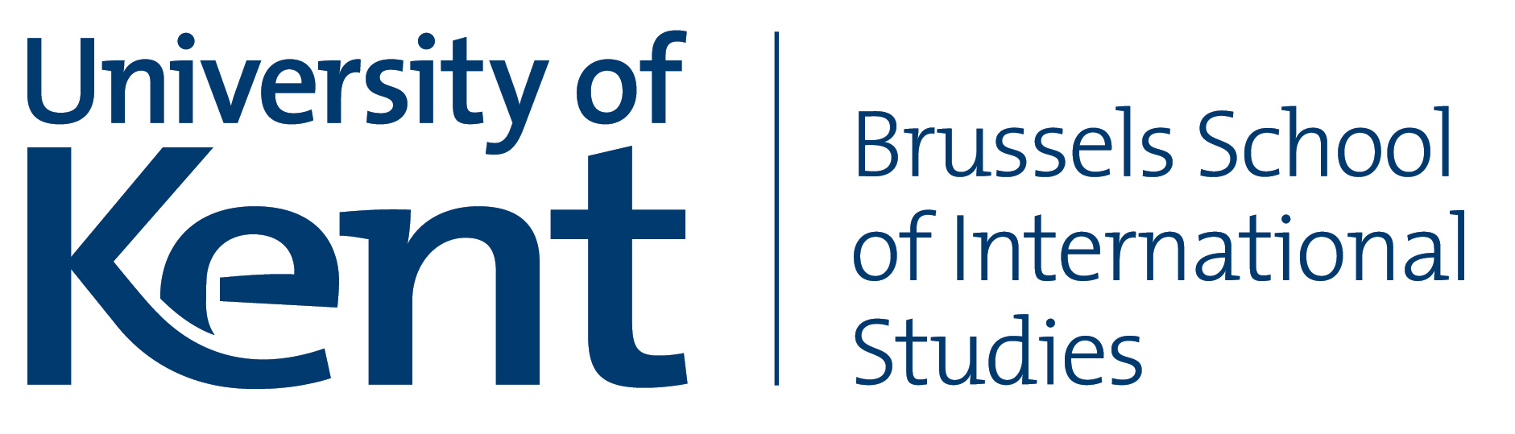 [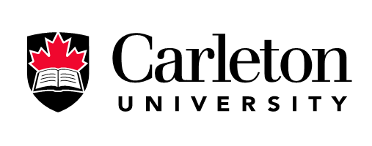](http://www.google.be/url?sa=i&rct=j&q=&esrc=s&source=images&cd=&cad=rja&uact=8&docid=SPSjX-7sUvtWvM&tbnid=cIpoKHGODpFmvM:&ved=0CAUQjRw&url=http://globalaccessibilitynews.com/2014/07/10/carleton-university-hosting-international-accessibility-summit-from-july-12-15/&ei=Y_vYU436DYTNygP5woLgDA&bvm=bv.71778758,d.bGQ&psig=AFQjCNHF_h57q4oj5MmxNvinNnhsAKRHRw&ust=1406)

Conference

**EU-RUSSIA RELATIONS**

**Which way forward?**

*Programme*

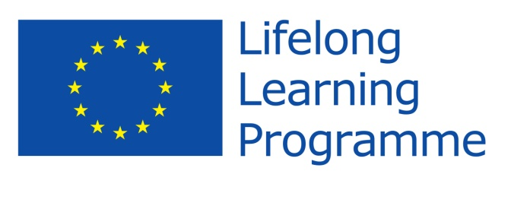

**With the Support of the LLP Programme of the European Union**

**St. Petersburg, School of International Relations**

**Ul. Smolnogo 1/3, entrance VIII**

**Friday, 26 June 2015**

**9:30 – 10:00 REGISTRATION**

**10.00 – 10.15 OPENING ADDRESS**

*Chair:* Dr Tatiana ROMANOVA, Associate Professor, St. Petersburg State University

Prof. Irina NOVIKOVA, Dean of the School of International Relations, St. Petersburg State University

**10:15 – 12.00 OPENING SESSION: The EU-Russia Relations – Bridging the Theory with the Practice**

*Chair:* Dr Tatiana ROMANOVA, Associate Professor, St. Petersburg State University

*Keynote speakers:*

Dr. Alexey GROMYKO, Director, Institute of Europe, Russian Academy of Science

Dr. Derek AVERRE, Director, Centre for Russian, European and Eurasian Studies, University of Birmingham

Prof. Konstantin KHUDOLEY, Chair of European Studies, Honorary Dean of the School of International Relations, St. Petersburg State University

Prof. Laure DELCOUR, Senior Research Fellow, Institut de relations internationales et stratégiques

**Q & A**

**12:00 Coffee Break**

**12:30 – 14.15 SESSION I: Regional Integration Initiatives in the Common Neighbourhood**

*Chair:* Dr Tom CASIER, University of Kent – Brussels School of International Studies

*Topic Presenters:*

Prof. Joan DEBARDELEBEN, Professor, Institute of European, Russian and Eurasian Studies, Carleton University

Dr. Crina VIJU, Assistant Professor, Institute of European, Russian and Eurasian Studies, Carleton University

*Topic Discussants:*

Prof. Roy ALLISON, Head of Russian and East European Studies, School of Interdisciplinary Area Studies, University of Oxford

Dr. Kirill ENTIN, Associate professor, National Research University 'Higher School of Economics'; Research fellow, Centre for Comprehensive European and International Studies

Dr. Evgenyi TRESCHENKOV, Associate Professor, School of International Relations, St. Petersburg State University

Prof. Richard YOUNGS, Professor of International and European Politics, the University of Warwick, Senior Associate, Carnegie Europe (via skype)

**Q & A**

**14.15 - 15:30 Lunch**

**15:30 – 17.15 SESSION II: Mutual images on minority policies of Russia and the EU**

*Chair:* Prof. Dr Arne NIEMANN, Department of Political Sciences, Johannes Gutenberg University at Mainz

*Topic Presenter:*

Dr. Petra GUASTI, Johannes Guttenberg University Mainz

*Topic Discussants:*

Dr Mindaugas KUKLYS**,** Senior Research Associate, European Centre for Minority Issues

Dr. Serguei SEREDENKO, Human Rights Lawyer, Tallinn

Prof. Peter VAN ELSUWEGE, Professor, Ghent University

**Q & A**

**Saturday, 27 June 2015**

**10:00-11.45 SESSION I: Energy Relations: Perception and Realities**

*Chair:* Prof. Joan DEBARDELEBEN, Professor, Institute of European, Russian and Eurasian Studies, Carleton University

*Topic Presenter:*

Dr. Tatiana ROMANOVA, Associate Professor, School of International Relations, St. Petersburg State University

*Topic Discussants:*

Dr. Andrey BELYI, Senior Researcher, Tartu University

Prof. Nikolai DOBRONRAVIN, Department of World Politics, St. Petersburg State University

Dr. Simon PIRANI, Senior Research Fellow, the Oxford Institute for Energy Studies

Dr. Jack SHARPLES, Associate Professor in the Department of Political Science and Sociology, Lecturer in Energy Politics in the Department of International Programmes, European University at St. Petersburg

**Q & A**

**11:45-12.15 Coffee break**

**12.15-13.45 SESSION II: EU and Russian Attitudes towards Multilateralism**

*Chair:* Prof. Dr Arne NIEMANN, Department of Political Sciences, Johannes Gutenberg University at Mainz

*Topic Presenter:*

Dr Tom CASIER, University of Kent – Brussels School of International Studies

*Topic Discussants:*

Dr. Derek AVERRE, Director, Centre for Russian, European and Eurasian Studies, University of Birmingham

Dr. Dmitry LANKO, Associate Professor, School of International Relations, St. Petersburg State University

Dr. Andrew MONAGHAN, Senior Research Fellow with the Russia and Eurasia Programme, Chatham House

Prof. Larisa DERIGLAZOVA, Professor, Tomsk State University

**Q & A**

**13:45-15.00 Lunch**

**15:00 – 17.00 Brain-Storming Session – What Policy Recommendations? – Roundtable Discussion**

all panels’ participants

**17:00 Conclusion**